For Critical Design Process and stages after this, the team is divided into 5 groups as following:

* **Mechanical Design Team**
* Sarah Naeem
* Jawad Akbar
* Hamza Hussain
* Muhammad Hassan Kazmi
* **Spraying Mechanism**
* Saad bin Tariq
* **Business Plan & Outreach**
* Muaz
* **Electric Power & Propulsion Design Team**
* Hassaan Ghazali
* Ali Khalid
* **UAV Control & Computing System**
* Muhammad Adeel
* Ahmad bin Mushtaq

Following is Project Workflow Chart for all 5 teams:

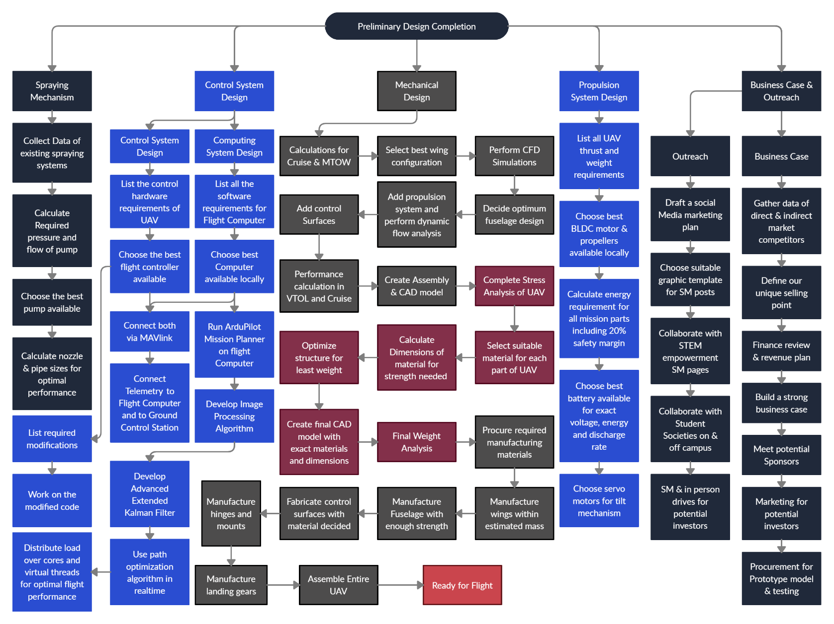

# A summary table for Resourcing, manufacturing & risks:

|  |  |  |  |  |  |  |
| --- | --- | --- | --- | --- | --- | --- |
| Project Part | Skillset | Resources | Procurement | Manufacturing/ Development | Risks | Mitigation |
|  |  |  |  |  |  |  |
|  |  |  |  |  |  |  |
|  |  |  |  |  |  |  |
|  |  |  |  |  |  |  |
|  |  |  |  |  |  |  |
|  |  |  |  |  |  |  |
|  |  |  |  |  |  |  |

Project is managed using Project Tracker on Google Drive. All files in project including CAD models, reports, simulations, source codes, etc. are managed on [GitHub repository](https://github.com/AhmadBinMushtaq/UAS_Challenge). All groups in the team work on different branches in repository.

Weekly team meetings are held on MS Teams which are compulsory for all members. Progress of each group, issues with design and other updates related to the project are discussed in these meetings. Any proposed modification in project plan is considered and the team tracker is updated accordingly.

Other than the weekly meetings, groups communicate regularly over WhatsApp informally and over email formally with the faculty advisor.